The Wisdom Global School
Subtraction, Addition, Multiplication And Division Of Fraction
(Butterfly Method)
Time:

Subtracting Unlike Fraction

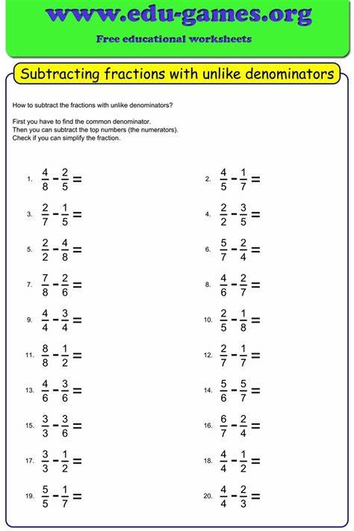

Word problems-

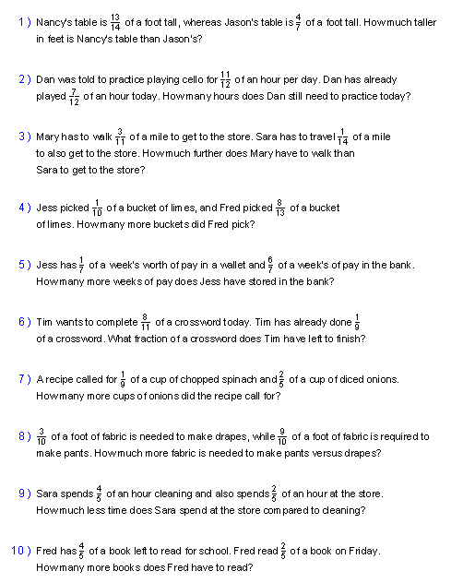

Adding Unlike Fraction

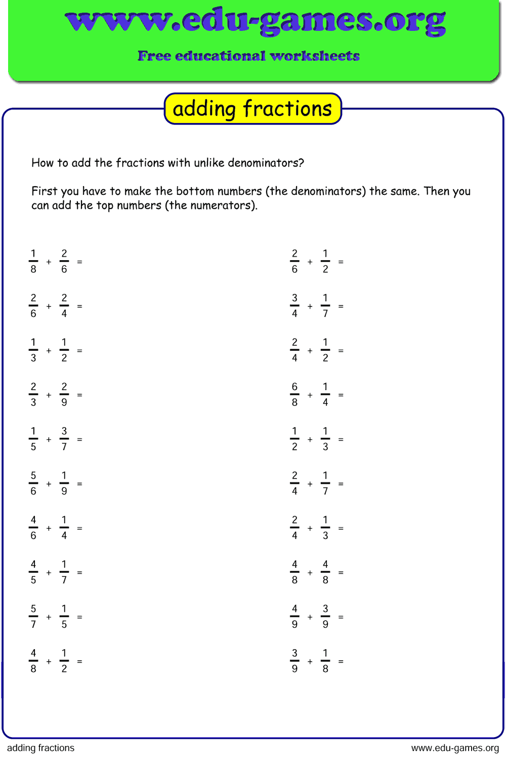

Word problems-

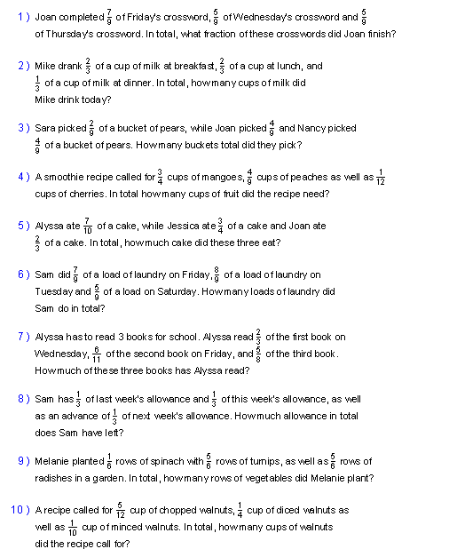

Multiplication of fraction

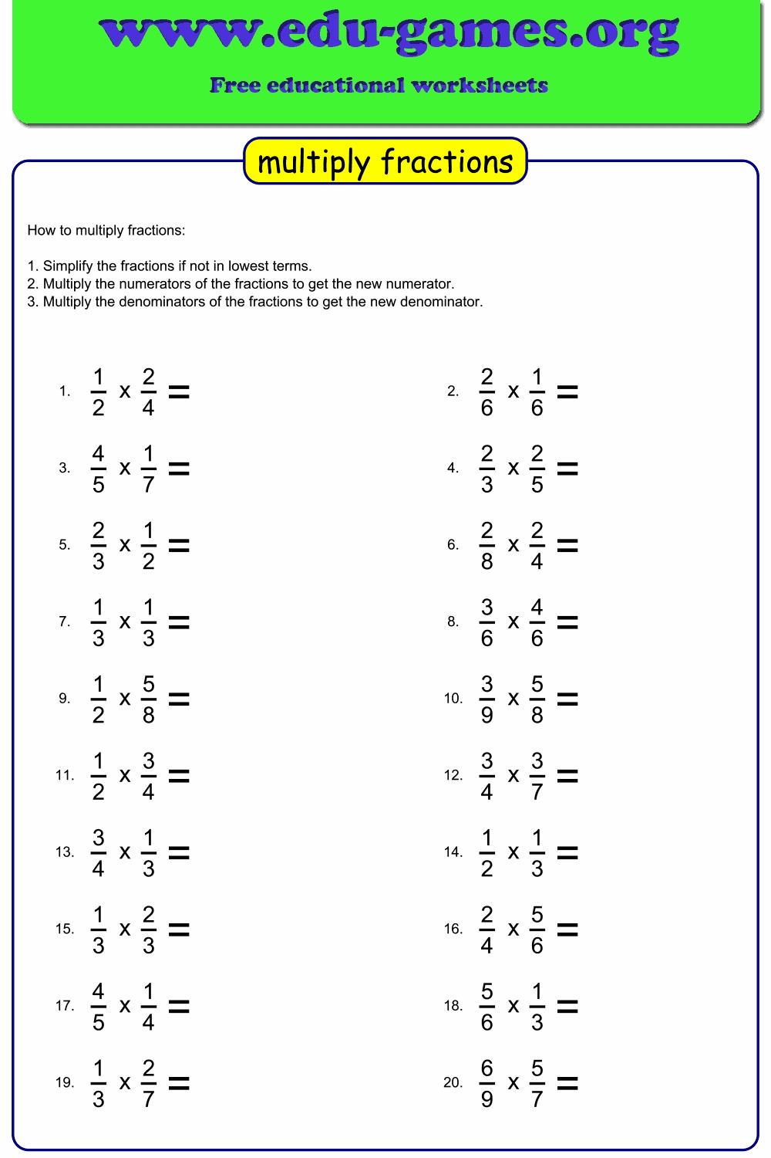

Division of fraction

