The Wisdom Global School
Arranging Fraction
(Gap Method)

Time:

Ordering the Fraction

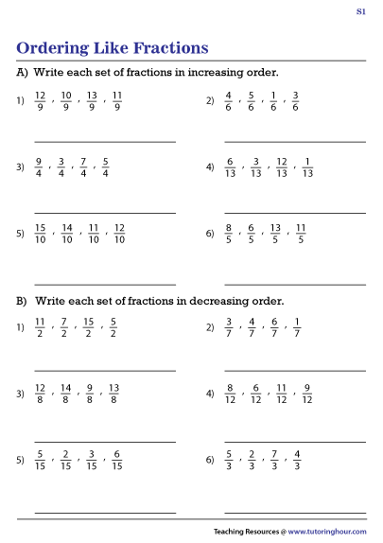

Arrange in Ascending Order

Arrange in Descending Order

